To ABC electricity distribution DNO or IDNO  99 West St, Imaginary Town, ZZ99 9AA abced@wxyz.com | Form C

Use this form to apply to connect new or additional heat pump equipment rated over 75A per phase.

This form shall be used for equipment rated up to 75A per phase that does not meet the requirements of standards BS EN 61000-3-2 or BS EN 61000-3-12 and BS EN 61000-3-3 or BS EN 61000-3-11. Note that these standards define limits that control specific types of power quality disturbances.

Where the equipment meets the requirements of standards BS EN 61000-3-2 or BS EN 61000-3-3 use Form A. Where the equipment meets the requirements of standards BS EN 61000-3-11 or BS EN 61000-3-12 use Form B.

The application must be made in advance of connection.

Please note that the normal standard of service for approval of connection are as follows:

- 25 working days - Properties with potentially disruptive loads
- 35 working days - Properties requiring high voltage network works.

Please note any reinforcement costs may be recharged to the customer.
Electricity Customer at site
Customer contact telephone
Site address
Post Code
MPAN - Unique identifying number for electricity meter at property | xx – xxx – xxx- xx –xxxx –xxxx –xxx

Existing Space & Water Heating System |  |  |  |  | Electric/Gas/Oil/LPG/Other |  |  | …………….
If Electric then please complete the following:
Existing space & water heating  equipment | Direct acting heaters | Storage heaters | Hot water immersion heaters |  | Heat pump system |  |  | Other  Inc. Flow Boilers
Existing space & water heating  equipment | Direct acting heaters | Storage heaters | Main | Boost | Compressor | Boost | Back-up | …………….
Existing space & water heating  equipment | kVA | kVA | kVA | kVA | kVA | kVA | kVA | kVA

Existing space & water heating  equipment to be retained | Direct acting heaters1 | Storage heaters2 | Hot water immersion heaters |  | Heat pump system |  |  | Other  Inc. Flow Boilers
Existing space & water heating  equipment to be retained | Direct acting heaters1 | Storage heaters2 | Main | Boost | Compressor | Boost | Back-up | …………….
Existing space & water heating  equipment to be retained | kVA | kVA | kVA | kVA | kVA | kVA | kVA | kVA

New space & water heating  equipment | Direct acting heaters1 | Storage heaters2 | Hot water Immersion heaters |  | Heat pump system |  |  | Other  Inc. Flow Boilers
New space & water heating  equipment | Direct acting heaters1 | Storage heaters2 | Main | Boost | Compressor | Boost | Back-up | …………….
New space & water heating  equipment | kVA | kVA | kVA | kVA | kVA | kVA | kVA | kVA
Heat pump system details |  | Manufacturer
 |  | Type reference
Operating Voltage (V): |  |  |  | Volts
Phases (1 or 3)
Heat pump system maximum electrical power requirement |  |  |  | kVA
Note: heaters not fitted in the heat pump unit to boost hot water temp or as a back up should be recorded as new equipment above or as existing equipment to be retained below as appropriate.

Required Maximum Capacity for Whole Customer Installation | kVA

I confirm that the electrical installation noted above will be installed and commissioned as noted above and that the equipment does not meet the requirements of BS EN 61000-3-2, BS EN 61000-3-3, BS EN 61000-3-12 and BS EN 61000-3-11 for harmonic emissions and voltage change. The customer at the above address has been advised that commissioning of the installation may only take place when the Network Operator has completed any reinforcement works the supply network requires.
Name |  |  | Signed |  |  |  | Date
On behalf of Installer
Accreditation / Qualification
Installer address

Post code
Contact person |  |  |  | Telephone number
E-mail address

Heat Pump System Power Quality Data (essential)

Note: The manufacturer may need to be consulted to complete this technical data.

Heat pump system details | Manufacturer
Heat pump system details | Type reference

EC Declaration of Conformity | Attach the manufacturer’s EC Declaration of Conformity as produced in association with the EMC Directive | Attached?
EC Declaration of Conformity |  | Yes/No?

Harmonic Emissions

Rated Current (A) |  |  | …………………………………………….…
Operating Voltage (V): |  |  | …………………………………….…………
Phases |  |  | …………………………………….…………

Maximum Value of Harmonic Currents for each Harmonic Order
Harmonic  Order ‘h’ | Emission  Current (A) | Harmonic  Order ‘h’ | Emission  Current (A) | Harmonic  Order ‘h’ | Emission  Current (A)
2 | ………….… | 20 | …………..… | 38 | …………....…
3 | ………….… | 21 | …………..… | 39 | …………....…
4 | ………….… | 22 | …………..… | 40 | …………....…
5 | ………….… | 23 | …………..… | 41 | …………....…
6 | ………….… | 24 | …………..… | 42 | …………....…
7 | ………….… | 25 | …………..… | 43 | …………....…
8 | ………….… | 26 | …………..… | 44 | …………....…
9 | ………….… | 27 | …………..… | 45 | …………....…
10 | ………….… | 28 | …………..… | 46 | …………....…
11 | ………….… | 29 | …………..… | 47 | …………....…
12 | ………….… | 30 | …………..… | 48 | …………....…
13 | ………….… | 31 | …………..… | 49 | …………....…
14 | ………….… | 32 | …………..… | 50 | …………....…
15 | ………….… | 33 | …………..…
16 | ………….… | 34 | …………..…
17 | ………….… | 35 | …………..…
18 | ………….… | 36 | …………..…
19 | ………….… | 37 | …………..…

Heat Pump Compressor(s) | Aggregate Electrical Rating | ………….kW/HP
Heat Pump Compressor(s) | Number of Compressors | Single/Twin/Other………………………..
Heat Pump Compressor(s) | Time-delay Between Starts if >1 Compressor | ………….minutes/seconds
Heat Pump Compressor(s) | Compressor 1:
Heat Pump Compressor(s) | Nominal Voltage | ………….V
Heat Pump Compressor(s) | Phases | 1 or 3 phase
Heat Pump Compressor(s) | Electrical Rating | ………….kW/HP
Heat Pump Compressor(s) | Maximum Starting Current | ………….A
Heat Pump Compressor(s) | Minimum Time Between Starts of Compressor 1 | ………….hours/minutes/seconds
Heat Pump Compressor(s) | Compressor Method of Starting | Direct On Line  Star/Delta  Auto-transformer  Electronic Soft Start  Variable Speed | Slip Ring Rotor Resistance  1-Phase Capacitor Start  Single Phase Series Parallel  Other…………………......  ……………………………...
Heat Pump Compressor(s) | Starting Power Factor | ………….
Heat Pump Compressor(s) | Compressor 2:
Heat Pump Compressor(s) | Nominal Voltage | ………….V
Heat Pump Compressor(s) | Phases | 1 or 3 phase
Heat Pump Compressor(s) | Electrical Rating | ………….kW/HP
Heat Pump Compressor(s) | Maximum Starting Current | ………….A
Heat Pump Compressor(s) | Minimum Time Between Starts of Compressor 2 | ………….hours/minutes/seconds
Heat Pump Compressor(s) | Compressor Method of Starting | Direct On Line  Star/Delta  Auto-transformer  Electronic Soft Start  Variable Speed | Slip Ring Rotor Resistance  1-Phase Capacitor Start  Single Phase Series Parallel  Other…………………......  ……………………………...
Heat Pump Compressor(s) | Starting Power Factor | ………….

Back-up Heater Details
Nominal Voltage | ………….V
Phases | 1 or 3 phase
Make | ……………………………………………
Model | ……………………………………………
Rating or Aggregate Rating | ………….kW/A
Number of heating stages switchable individually
 | Stage 1 | ……kW | Stage 6 | ……kW
 | Stage 2 | ……kW | Stage 7 | ……kW
 | Stage 3 | ……kW | Stage 8 | ……kW
 | Stage 4 | ……kW | Stage 9 | ……kW
 | Stage 5 | ……kW | Stage 10 | ……kW

Boost Heater Details
Nominal Voltage | ………….V
Phases | 1 or 3 phase
Make | ……………………………………………
Model | ……………………………………………
Rating or Aggregate Rating | ………….kW/A
Number of heating stages switchable individually
 | Stage 1 | ……kW | Stage 6 | ……kW
 | Stage 2 | ……kW | Stage 7 | ……kW
 | Stage 3 | ……kW | Stage 8 | ……kW
 | Stage 4 | ……kW | Stage 9 | ……kW
 | Stage 5 | ……kW | Stage 10 | ……kW
Description of power variations (with particular attention to step changes, ramped changes and repetition periods). Use most appropriate scale. Show minimum time between changes.

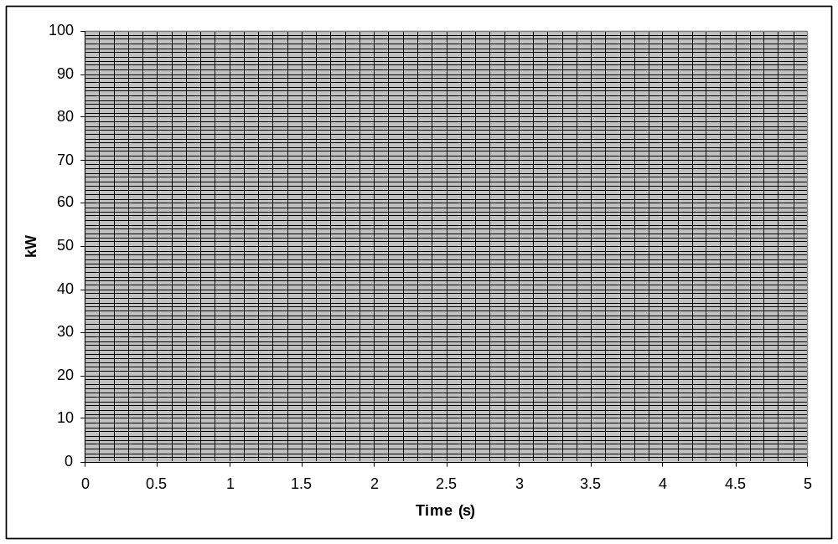
Repetition Period: …………  seconds/ minutes/ hours/ days

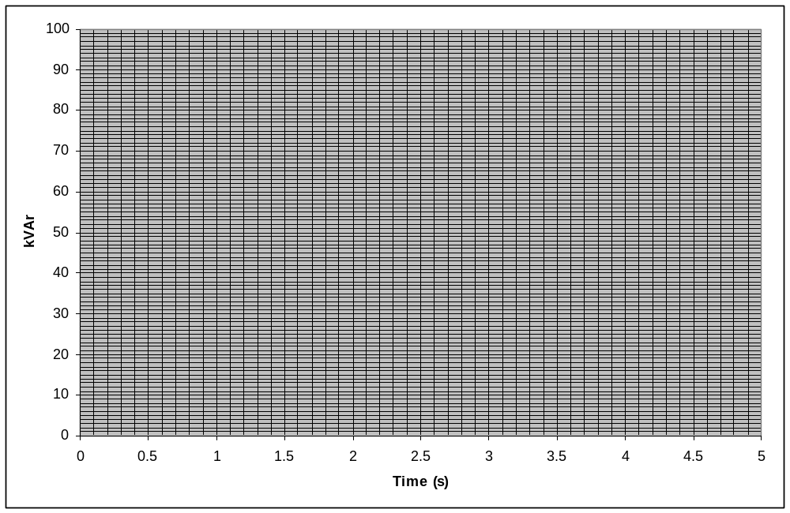
Repetition Period: …………  seconds/ minutes/ hours/ days

DNO Comments - to be completed by DNO representative following application

As a DNO representative, I give, in principle, permission for the connection of these heat pump units. If no, see comments below. |  | Yes/No
Comments (Use separate sheet if necessary)

Signed: | Contact: | Date:

Direct acting heaters are directly connected to mains (e.g. convector or panel heaters).
Storage heaters retain heat inside the storage heater, are charged over night to store heat and release heat during the day. Storage heaters often use Economy 7 electricity tariff at night.

